October 2017

Departnment of International Cooperation

mINISTRY OF pLANNING AND INVESTMENT

(Draft) Programme Based Approach

Contents

1. Background 1

2. Definition and principles of PBA 2

2.1 Definition 2

2.2. Principles of PBA 4

3. Steps for PBA application 7

Capacity Development 10

4. Limitations 10

5. Monitoring and Evaluation 11

Figure 1. National Socio Economic Development Plan with Funding and Implemenation Arrangement 2

Figure 2. Level of PBA Application with Alignment 5

Figure 3 Step for PBA Application 8

Table 1. Basic comparison of Programme-based and Conventional project approaches 3

# Background

In 2015, the Government of Lao PDR (GoL) endorsed the Vientiane Declaration on Partnership for Effective Development Cooperation, resonating with Development Partners in improving effectiveness and efficiency utilizing resources for development. The eight key principles outlined under the Vientiane Declarationon Partnership for Effective Development Cooperation are: Ownership; Alignment; Harmonization and Simplification; Inclusive Parnerships for Development Results; Transparency, Predictability and Mutual Accountability; Domestic Resource Mobilization; South-South Cooperation, Triangular Cooperation and Knowledge Sharing; and Business as Partner in Development.

Recently, there has been recognition that stand-alone project facing frustration, due to failure in coordination for synchronising multiple projects’ impacts; lack of recurrent expenditures; high transaction cost for delivery of the impacts; and parallel implementation system, particularly for off-budget systems. It is noticeable that stand-alone project is more on supply-driven and more focus on tangible outcomes – linking between inputs and outputs.

In this regard, the programme based approach (PBA) is put forward as a means to improve the effectiveness of aid while reducing transaction costs. A PBA is a policy based approach in which participating development partners (DPs) accept that the government is best positioned to understand the challenges of developmentand thus join forces to help the government implements its policy/approach to overcome the challenge. The PBA automatically meets the aid effectiveness goals of ownership and alignment by focusing on supporting the government’s own policies and implementation plans. Furthermore, by advocating a multi-donor approach the PBA is contributing to harmonisation. Finally, if done effectively, the PBA is designed to deliver measurable results whilst creating a space for effective dialogue and thus mutual accountability.

A PBA directs DP’s resources at improving delivery on government strategy and policy. It is significant for the DP to both support government policy and recognise the inherent ranking of policy priorities. Currently, the Government of the Lao PDR is implementingthe 8th Five-Year National Socio-Economic Development Plan (NSEDP) under which resources are required. In this context, multiple sources of funding will be mobilized. It is foreseeable that the conventional project based approach is insufficient. In order to facilitate the implementation of the NSEDP with sufficient budget mobilization thus any PBA modalities are required. Moreover; the PBA will also enhance and promote synergy among cross-sector linkage and complementary of each related program.

Most PBA implementations in the Lao PDR are designated to “financing modality” which are demonstrated in the form of “sector buget support”, aiming to accelerate the Government’s priority development plan, for instance, Health Governance and Nutrition Development Project, Poverty Reduction Funds (the World Bank Group financing); Health Governance Program (ADB financing), Basic Education Quality and Access (Australian financing), UXO trust fund and the Government of Janpan also contributes to the Poverty Reduction Funds. In addition, Lao PDR has implemented PBA in the form of “pooled funding” which supported by the multi-development partners such as, Australia, Switzerland and France. The share of PBA related types in the ODA supported to Lao PDR is about 6% out of the total amount 654 million (OECD DAC, figured 2015).



#### Figure 1. National Socio Economic Development Plan with Funding and Implemenation Arrangement

# 

# Definition and principles of PBA

In order to apply PBA in practice, it is necessary to understand the concept and principles of PBA, particularly PBA for aid. At first, developers will need to be able to distinguish between project aid and budget support and theirs characteristics. This guideline is giving a general definition for project to its effectiveness, efficiency as well as a comparison to programmes with principles related to PBA.

## 2.1 Definition

By definition, a project is simply defined as a collaborative endeavour to achieve a specific objective within a defined timeline and cost. A project is generally characterized by a scope, deliverables, benefits, workplan, resources, time and cost.  In term of external supporting project, activities conducted with a specific objective, budget and timeframe to achieve targeted results, where the identification of a specific area of intervention for donor involvement have been defined. The success of a project is observable by the level of commitment, coordination and the impact on the objective or the targeted issue.

The effectiveness of the project is not defined by resources employed, but normally defined by the impact of the Project outputs. On the other hand, the project efficiency is solely based on the timeline and allocated resources. In order to improve the effectiveness and efficiency of the project, there needs to be an effective monitoring and evaluation mechanism in place.

In a complex environment where a project scope is large and complicated, the balancing of effectiveness and efficiency of the Project is a constant challenge, particularly the compromise between resources, timeline and deliverables is unavoidable. To overcome such issue, coordinated and collaborative simple projects are necessary, leading to the implementation of multiple projects or programme.

##### **Table 1. Basic comparison of Programme-based and Conventional project approaches**

|  |  |
| --- | --- |
| Programme-based approach | Conventional project approach |
| Country’s overall view on entire sector or policy area | emphasized support to narrowly  defined objectives |
| Partnerships with mutual trust and shared accountability | Recipient accountable to donor |
| External partners’ co-ordination and  collective dialogue | Bilateral negotiations and agreements |
| Increased use of local procedures | Parallel implementation arrangements |
| Long-term capacity/systemdevelopment in sector | Short-term disbursement and success of  projects |
| Process-oriented approach through learning by doing | Step-by-step approach |

In this regard, a programme is defined as “A group of related projects managed in a coordinated way to obtain benefits and control not available from managing them individually”. In recent times, Programme Based or Sector Wide Approaches are commonly adopted.

Under the definition of the OECD DAC: “Programme-Based Approaches (PBAs) are a way of engaging in development cooperation based on the principles of co-ordinated support for a locally owned programme of development, such as a national development strategy, a sector programme, a thematic programme or a programme of a specific organisation. Similarly, the term Sector Wide Approach (SWAp) refers to a PBA implemented at the level of an entire sector or policy area, which also follows similar principles to a PBA.

To simplify, a Program Based Approach is defined as an aggregation of activities and policies leading to the comprehensive and coordinated planning and implementation of activities under the ownership of the partner governments. For aid modality, program assistance is generally accompanied by the necessary capacity building that will increase the absorptive capacity of partner countries. It is important to note whether the various types of assistance provided by different donors are appropriately coordinated in the program implementation and whether the coordination and the aid modalities are well-suited to the recipient government’s capacity and needs.

Programme-based approaches are normally implemented when there is a clear involment and clearly defined process, including leadership by the host country or organisation, a single comprehensive programme and budget framework; a formalised process for donor co-ordination and harmonisation of donor procedures for reporting, budgeting, financial management and procurement; and efforts to increase the use of local systems for programme design and implementation, financial management, monitoring and evaluation.

The PBA in development cooperation is directly supporting the implementation of government strategy and policy and involves development partners, developers, governments as well as beneficiaries working effectively together to achieve a common ultimate goal. The over-arching medium term development plan which is comprised of projects and programmes derived from sector strategies and policies. A PBA is therefore an attractive option for resource mobilization and enhancing of effectiveness of development.

It should be noted that a PBA has no fixed layout, but rather a dynamic process of development cooperationwhere mutual accountability and understanding serves as the basis for the startup

## 2.2. Principles of PBA

A PBA can be implemented with any or a mix of modalities but is always based on a shared understanding of the sector challenges and the need for development partners to support government policy. PBA modalities can be a support through multilateral supports, basket/pooled funds, budget supports or core supports. Selecting a PBA modality will reflect the level of alignment with national systems. Currently there are five types of PBA modalities depending on level of alignment with government policy and system. The alignment levels are ranking from pararell financing to general budget support. However, sometimes there are misconcept of PBA or similar type of programme base, such as Sector Wide Approach (SWAp), that programme based is solely budget supporting scheme.

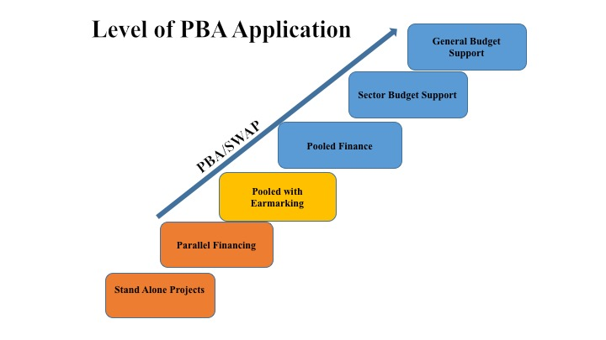

#### Figure 2. Level of PBA Application with Alignment

The figure 2 shows the level of PBA Application, where the alignment to national policy is the key determint for type of PBA. Each level of PBA application depends on the readiness and agreement between the government or owner of policy and development partners. The arrangement for adopting PBA can be vary and depends on condition, including the arrangements for management, financing, procurment, implementing, coordinating, monitoring, reporting, evaluating and staffing.

Regardless of modalities, a program and a PBA should adhere to the following 10 principles:

1. Ownership: The Government takes the leading role in implementing the PBA and takes necessary measure to ensure its success. The respective line ministries, local authorities and key development partners fully agree, endorse and support the PBA.
2. Consessus on the concept and principles of PBAs – at central as well as at sector levels.
3. Sector/programme strategy: PBA needs to be firmly guided by national policies and strategies starting with existing policies, development plans, systems and national capacity. A fundamental starting point of applying a PBA is a clear definition or understanding of the sector or area of intervention by all involved key stakeholders and partners.
4. Agreed comprehensive workplan and budget framework whereby clear priorities need to be developed, including a medium-term expenditure framework that reflects the sector strategy and arrangements of resources to support the sectors. This has to be approached through engagement in strategic dialogue with development partners.
5. Results driven approach, which includesa mutually agreed set of objectives, results and selected indicators that measures progress including a respective monitoring process that strengthens accountability provide the framework for a PBA by all stakeholders.
6. Clear and streamlined process for dialogue, coordination and cooperation: An effective mechanism for dialogue, coordination and cooperation among all key stakeholders needs to be established at all levels. This could be formalized through an agreed Terms of References defining roles and responsibilities.
7. Inclusiveness and transparency: inclusiveness, transparency and accountability are an essentialelement inplanning, budget and follow-up processes toensure that all relevant stakeholders and actors are included.
8. Harmonisation and alignment: Taking into consideration the current state of country systems and country capacities, all stakeholders should put more efforts into increasing the use of national systems for programme design and implementation, financial management, procurement, monitoring and evaluation, and reporting.
9. Strengthening of national capacity at both individual and institutional levelsthrough coordinated and systematic efforts.
10. Mutual accountability: Promote ownership, and mutual accountability toensure that objectives, commitments and roles are agreed by all stakeholders involved.

Rather than going into detail of each type PBA advantages and challengest, this guideline will comprise simple chart of comparison by using evaluation criteria, i.e relevance, effectiveness, efficiency, impact and sustainability as in annex ??. The chart summarizes keys advantages that budget support is one of modality that preferable by the host country. However, pooled funding or pararelling/co-financing for project intervention persist valid once agreement for supporting specializing agency – agency that have comparative advantage to implement interventions. The capacity and national system remain to be precondition for applying such a form of PBA.

In order to deepening understanding about PBA, particularly on budget support types, this guideline will briefly discuss key advantages and challenges of budget support modalities. Budget support is an aid modality that is directly channelled funds into the financial management of country structurly and systemically, which will improve accountability and procurement systems of ້host country so that they can manage development programmes and policies according to national priorities. Budget support modalities are intended to strengthen accountability and alignment, which support the principles laid down in Global Partnership for Effectiveness Development Cooperation as well as locally Vientiane Declaration on Partnership for Effective Development as the successor of Paris Declaration on Aid Effectiveness.

Budget support is used for ensuring country ownership and supporting for complementary institutions and processes to be strengthened that make development efforts more sustainable and long-term. To ensure for positive outcomes of budget support, a full budget transparency of aid activities in the country for both on and off-budget should be in placed. It is also noticeable that budget support provides key advantages over project-based as: (1) Highly harmonised programe for development will avoid aid and project proliferation and fragmentation; (2) Reduce transation closts, special staffing arrangements, particularly pararellel structure; (3) Long-term commitment will sustain the implementation of development stratregies, where the outputs are sychonized leading to achiving ultimate outcomes; (4) Strengthen predictability and timeliness of external support that requires for leveraging the implementation of development strategies at the national level; and (5) Strengthen national capacity and accountability, particularly on management of public resources. On the other hand, there are some limitations that need to be aware of when applying budget support modalities, particularly the precondition for applying such modality that is (1) functional PFMs, which transparency and integrity are centerpiece of PFMs; and (2) attribution of the development is difficult to see, for instance in the construction of a bridge, it is simple to see the cause and effect of the project, in constrast with budget support this observable results is difficult to see.

# Steps for PBA application

To ensure the successful application of PBA under ODA regulations, the roles of the Government and Developement Partners are determined as follow :

The Government and its Line Ministries take the leading role in initiating the processes of PBA Application. During the identification phases, the Ministry of Planning and Investment (MPI) acts as the interlocutor with Development Partners and ensures that Development Partner plans are aligned with the NSEDP and that financial allocations to sectors represent a good use of resources. The responsible line ministry works jointly with contributing DPs through the relevant sector working group in the process of designing the PBA. Line ministries are responsible for ensuring that the PBA priorities reflect the medium term priorities of the line ministry, that the Development Partner is using the correct sector definitions (i.e. government definitions clearly delineating line ministry mandate and policy framework).

Meanwhile, Development Partners  are also called on to work with their respective headquarters to enable greater use of PBAs in Laos. A key aspect to improving the effectiveness of development cooperation and enabling PBAs is for development partners to decentralise decision making to the country level and to work as possible to synchronising their programming with the Government’s fiscal year. Development partners are also urged to implement their existing commitments to improving division of labour through which a single coordinating development partner is appointed for each sector: the coordinating development partner should act as a ‘one stop shop’ to provide information to government and other stakeholders on all development partner programming in the specific sector. The DP may opt to play a lead or active role in the sector in addition to generally supporting a PBA. This means the DP takes on the added responsibility of promoting the PBA as the preferred means of programming in the sector. Added value is created when the DP also commits to demonstrating the value of government policies that inform the particular project or programme and to focusing on lessons learning to improve policy, implementation and coordination with other development partners. This means supporting government led coordination and capacity for monitoring, reporting and oversight.

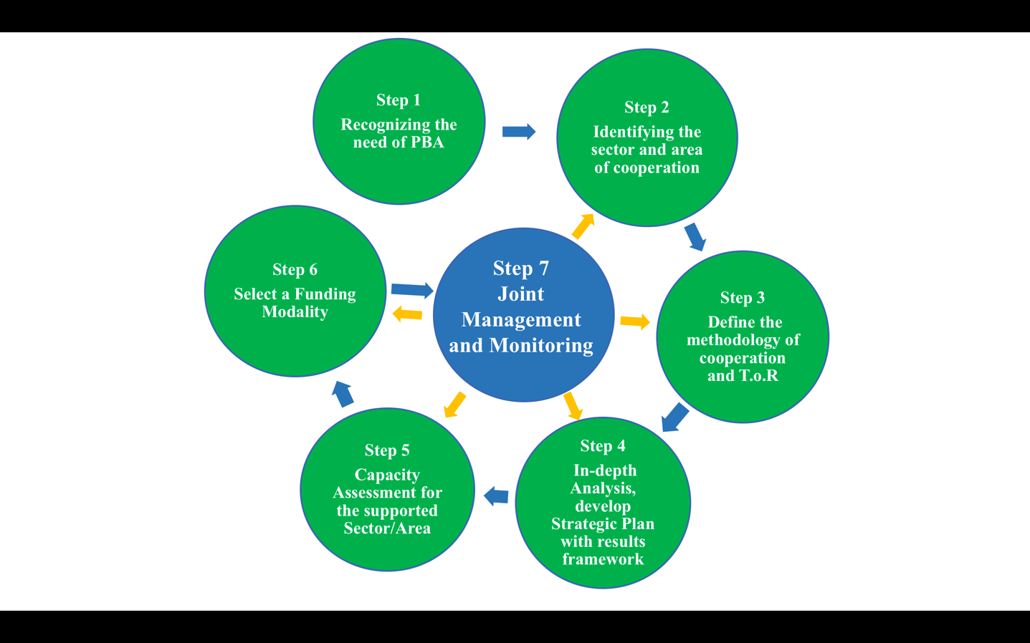

#### Figure 3 Step for PBA Application

While the PBA implementation process may vary on a case-by-case basis and is dependant on a specific context, it can commonly be separated into7 different steps as follow:

**Step 1 –Recognizing the need of PBA**

To achieve a basic understanding on the underpinning principles of PBA as well as basic tools and methods for implementation, the Government and Development partners are advised to start with a joint analysis of the policy environment covering:

1. Sector specific policies and strategies,
2. The sector classification and performance indicators as listed in the most recent NSEDP,
3. Sector budgeting and its medium term expenditure framework,
4. Sector coordination and stakeholder mapping including with development partners, and important non-state actors,
5. Organisational enabling environment and capacity assessment,
6. Performance monitoring systems and the partner’s reporting cycles,

The Government and Development Partner then use the analysis to make an in principle decision on whether or not to pursue a PBA. Once the decision is made, the DP and government communicate with sector stakeholders and elaborate a timetable for formulation and further consultation as needed. It is also essential at this stage to manage expectations as to what the intervention will achieve and how long it will take to come to fruition.

**Step 2 – Identifying the sector and area of cooperation**

The Government, Development Partners and related stakeholders must develop a thorough understanding of the sector or area of cooperation as well as the overarching context. It is essential for all stakeholders to agree on the prioritized areas of cooperation, identify the synergy of prioritized areas, key challenges, needed resources, major stakeholders involved as well as existing policies and strategies. It is recommended for the stakeholder to refer to the joint-analysis mentioned in Step 1 in order to carry out an initial assessment of “PBA Readiness”.

**Step 3 – Define the methodology of cooperation and T.o.R**

After the areas of cooperation have been identified, the Government and DP must agree on the basic principles of implementation, agree on a roadmap and establish roles for stakeholders by developing a clear T.o.R. The agreement shall include:

* the roles of the different stakeholders and division of labour,
* the key references for PBA implementation, such as the workplan (both project cycle and annual workplan), the medium term expenditure frameworks, guideline for monitoring andevaluation,
* modality and quotency of consultations,
* decision-making mechanisms,
* Information-sharing mechanisms,
* the details of commitments of all stakeholders.

The T.o.R should be prepared under leadership of the Government (ministry, institution, and organisation) in close consultation with development partners. In addition, the T.o.R should promote the spirit of mutual commitments and responsibility in order to ensure an equal partnership between the stakeholders.

**Step 4 – In-depth Analysis and Strategic Plan for supporting Sector/Area with results framework**

Once the methodology of Cooperation is defined, the Government and Development Partners must conduct an in-depth analysis of the sector/area to verify the needs, feasibility and redundancy of existing or emerging strategic sector perspectives. Based on the result of this analysis, a Strategic plan is developed. Strategic Planning should focus on the sub-sector/area level while considering the overall sector perspective. In the process of setting objectives and targets for the strategic plan, it is vital that the Government and development Partners consider existing plans, budget and results-related documents and Assess the need for revision and additionsto existing policies and strategies.

**Step 5 – Capacity Assessment for the supported Sector/Area**

Capacity Assessment of the Government and Development Partners both at institutional as well as individual levels is usually conducted to assess the effective of the Government and Development Partner’s impact in the sector.

Capacity Development is another key component of development effectiveness and sustainability. Accordingly, it is essential to develop and implement a Capicity Building Plan for all related Stakeholders in order to improve their capacity to manage challenges, deliver essential services and develop responsive, legitimate and accountable institutions. In addition, it is recommended to conduct reviews of designated experts and technical staff capacity on a regular basis to promote their Engagement.

**Step 6 – Select a Funding Modality**

The Process of Funding Modality Selection must be results-based rather than input-control based. When planning a PBA, the stakeholders may choose between a number of funding modalities, including support through multilateral organizations, joint funding modalities such as basket/Trust/pooled funding, co-financing or delegated financing. In any case, stakeholders are strongly encouraged to promote the use of country systems, Budget Support or Core Support.

**Step 7 – Joint Management and Monitoring**

Once the Government and Development Partners have reached consensus on the definition, objectives, goals, outcomes and indicators of the PBA, they will need to agree on a Joint Management and Monitoring mechanism. For joint-monitoring, a common form shall be agreed to based on existing data and national systems for collection and follow-up. For joint-management and monitoring, result-based management or similar exercices with clearly defined potential risks and joint measures to be taken are ideal. In addition, it is recommended to develop a joint information-sharing system, encourage the use of national systems, conduct regular analysis of capacity of joint-managaement and monitoring as well as promote good lessons learnt from existing joint-management exercices.

# Limitations















The application of PBA rests fully on the ownership of the host country, particularly the development of socio economic development plan, which emphasizes and focuses on programme based/sector wide results. The linkages of inputs and outputs model do not fully sastify the need of the national development plan, thus a PBA or sector wide approach can enhance the impact and effectiveness. However, some pre-conditions must be considered prior to applying such modality, in particular the analytical capacity for development policy, managerial capacity of the government agency, sound and effective medium term expenditure framework (both national and sectoral levels) with clear regulations and guidelines, continous improved national systems, prioritized development programme or sector priorities, monitoring framework that allow state and non-state actor to track and follow up the progress of implementaiton of both on-off budget intervention implementation and existing platform for dialoge and coordination. More importantly, both host country and development partners should commit to fiduciary risk assessments and longer information plan of 3-5 year activities. Timing is one of the key challenges and limitations of PBA or SWAp since the start-up costs of establishing joint monitoring frameworks and the process is very time consuming.

In order to overcome capacity constraints, the government should ensure that the functioning of the entire national system is to be improved/developed across a wide range of organizations and at all levels including capacities for: (i) financial management and accountability; (ii) planning and designing development programs; (iii) implementing programs and delivering services; (iv) developing viable data bases on development results and process indicators; and (v) monitoring and evaluating performance. However, DPs should also be encouraged to gradually use national systems as well as supporting capacity development to guarantee successful application of PBA for development.

# 

Monitoring should be incorporated into government’s own reporting and monitoring systems either by using nationally produced reports as reference points or designing DP monitoring to directly contribute to the country’s own government systems. Using common performance and monitoring systems is the basis for productive dialogue on results based management. When a budgetary support modality is used that releases disbursements based on government performance, it is essential that government officials have both the capacity and authority to deliver as well as to report on the specific deliverables being monitored.

The PBA involves monitoring results and creating a mutually agreed language on what constitutes successful delivery and whether the intervention logic continues to be viable. The PBA should focus more on outcomes as well as achievable outputs. Joint monitoringis encouraged to be used for effective PBA management. In this context, it is important to integrate reports on the project or programme into national reporting systems.

Unlikethe typical evaluation process for the evaluation of programme based projects, a PBA process contributes to better understanding by both the government and development partners, of implementation and capacity challenges and/or the need for policy reform. Therefore, joint evaluations between the Government and Development Partners are recommended.The joint-evaluation exercice also reports on whether identified and necessary changes to policy or implementation were made, whether there was productive policy dialogue in a conducive working relationship.

In order to monitor and evaluate the implementation of programme-based internation, both host country and development partners as well as stakeholders should agree on setting up common reporting, monitoring and evaluation system, which national database of development intervention shall be developed and used wisely. Joint develoment of such information sharing system will enhance accountability of both suppliers, tax payers as well local and beneficiaries.