Minutes of Meeting
Infrastructure Sector Working Group (ISWG)
Technical Consultation Meeting

Date: Friday 26th May, 2017
Duration: 08:30 to 12:00
Venue: Ministry of Public Works and Transport

- Introduction

The meeting was chaired by Dr. Oulay PHADOUANGDETH, Director General, Department of Planning and Cooperation, and co-chaired by the Representatives from Japan Embassy, Asian Development Bank, and World Bank. The Agenda of the meeting is in Annex 1. There were 26 participants representing Department of International Cooperation(DIC-MPI), Department of Planning and Cooperation (DPC), Department of Road(DOR), Department of Railways (DORW), Department of Transport (DOT), Department of Water ways (DOW), Department of Housing and Urban Planning (DHUP), Department of Water Supply(DOWS), Department of Civil Aviation( DCA), Asian Development Bank (ADB), Embassy of Japan and World Bank (WB), (the list of participants is in Annex 2).
- Opening remarks

The Chair thanked and welcomed participants from the departments within MPWT, DPs and DIC (MPI).The technical consultation meeting discussed the ISWG and SSWG’s agenda for 2017, particularly to, among other key issues, identify and confirm the current structure of the SWG, members, resource, topics, and priorities area of focus in 2017.

Co-Chairs from Japan Embassy:
Mr. Kurihara delivered an heartfelt appreciation for organizing the meeting hosted by the DPC. He mentioned in the remarks that some SSWGs and one ISWG were held last year, the mechanism of ISWG has been improving. He also said that it’s expected that emerging developing partners such as China, Korea and Thailand soon should join the mechanism.

Co-Chairs from WB:
Mr.Sombath Southivong appreciated MPWT’s efforts in taking the lead in organizing sub-sector working group meetings during the year and efforts made by development partners to improve the effectiveness of the ISWG platform. Progress has been made during the year. A number of infrastructure sub-sector working groups were conducted to discuss and made recommendations on key issues, particularly related to sustainability of the road sector development. However, there remain a need for further improvement of the ISWG and its sub-sector working groups in order that they can effectively be used as effective platform to support the sector development. This includes a need to deepen engagement in dialogue between MPWT and development partners from policy dialogue to concrete action plans and from just sharing information to establishment of common implementation and monitoring frameworks for the sector development, which would lead to application of sector-wise approach for the implementation of sector development regardless of sources of funding.

Co-Chairs from ADB:
Mr. Soulinthone Leuangkhamsing, Senior Economics Officer. ADB appreciated for the Co-Chair organized this Technical Infrastructure Sector Working Group Meeting. This sector is important as it shares a large proportion of the government infrastructure investment. I am looking forward to the presentations and discussion for the work plan and priority areas of the ISWG for 2017.

- Presentations

- Presentation 1:The Ministry of Planning and Investment, Department of International Cooperation presented on the result of the Round Table Process from 2016 and expectation 2017 – guidance to SWGs: By DIC-MPI

The presentation (reference Annex 3) covered 3 topics:
- Outcome of RTP 2016.
- RTP work plan and calendar of event 2017.
- RTP 2017 guidance to SWGs.

2. Presentation 2: ISWG Work plan 2017: by DCI-DPC-MPWT

The presentation (reference Annex 4) covered 5 topics:
- Review of Key issues/topics from 2016
- Lessons from ISWG 2016, Lesson from other SWGs/Discussion/option on new structure of SSWGs(and members)
- Propose 2017 ISWG Work plan
- Propose ISWG’s Calendar of event 2017
- Update Contact List
Based on the discussion the proposed new structure for further consideration was:

IV.Open Discussion
Questions and comments (Discussion points)
After the presentation, the Chair opened the floor to discuss:
- Comment by Mr. Soukaseum Dalasane, Department of waterway:
- Agree with the new structure of SSWGs as divided to 7 SSWGs.
- Suggest to give more importance to river transportation
- Comment by Mr Sengthavisay Malyvanh: Department of railway
- He informs the railway project priorities as 1. Lao-China railway project, 2. Vientiane-Thakhak-Muga railway project.
- He agree with the new structure of SSWGs and proposes that DPC should find donor to Support for feasibility study of Pakse-Veunkham railway and Savannakhet – Pakse – Vangtao railway projects.

- Comment by Mr Sengsouvanh Simphalyvong : Department of Civil Aviation
- He informs the progress of extension Wattay airport project.
- He Proposed donor for supporting Feasibility study for new VTE international Airport in Vientiane capital,Seno Airport in Savannakhet province, reconstruction of Xiengkhuang Airport, reconstruction of Hueixay Airport.
- Comment by Mr. Litta Khattiya: Department of Road
- He does not agree with the new structure because the old structure is already good and he suggested just to assign a secretariat/focal point of each department.
- DOR still needs a huge budget for road maintenance and also capacity building for DOR staffs.
- Comment by Dr. Saysavanh Phongsavanh: Department of Water Supply
- Department of Water Supply is still facing challenges with Climate change; Regulation of PPP, Regulating the water service quality and financial performance and she agrees with the new structure.
- Commentby Mr. Kurihara, EOJ:
  - Confirmed the provision of a technical advisor who is based within MPWT and that part of the TOR of the advisor was to support coordination which was the SWG and SSWG process. He hoped that MPWT will utilize this resource.
- Comment by Mr. Sombath Southivong: Representative from WB:
  - Raised concern over changing the structure of the SWG – noted that having additional meetings and additional structures would be a burden on MPWT. (this comment was well taken by the meeting and it was agreed that a new structure should not increase the burden of meetings and structures on MPWT).
  - Confirmed that WB was ready to support MPWT based on requests from MPWT.
- Comment by Mr. Soulinthone Leuangkhamsing: Representative from ADB:
  - Confirmed the importance of the SWG and RTP and ADB support to the processes. Confirmed the importance and need for government to take greater ownership in the process and that ADB is ready to provide support under this process.
  - The current arrangement of the ISWG is appropriate, but there is a need for further strengthening of the secretariat working group especially the coordination among departments at MPWT. ADB will continue to provide the logistic support until the end of this year.

V. The Outcome of meeting:
After open discussions, the meeting agreed on the following actions:
- Work plan 2017 is accepted
- ISWG’s Calendar of even 2017 and update Contract lists are accepted
- - Agreement on the need to change the structure, but agreement on retaining the old structure until the next meeting at which point agreement will be made on the best way forward (structure).
- The new structure will be discussed and agreed in the next SSWGs meeting
- The next meeting will be held at VangVieng by the end of June

VI.Closing remarks

The Chair thanked everyone for their valuable time in attending the meeting and thanked all for their comments and recommendations raised during the meeting. The chair found the meeting to be very productive and discussion was focused on key issues. The chair wished all participants good health, success in their work and happiness in their life, and hopes to meet all at the Sub- Sector Working Group Meeting that will be held at the end of June 2017.

Chair of Meeting Recorder

Dr. Oulay PHADOUANGDETH Chanthavong BOUNSOMBATH

ANNEX 1: MEETING AGENDA

Infrastructure Sector Working Group
Technical Consultation - Chair and Co-Chair meeting
------------------------------------------------------------------------------

Date: Friday 26 May 2017
Time 09:00 – 12:00
Venue: Meeting Room Number 2, Ministry of Public Works and Transport (MPWT)

Tentative Agenda
Time | Description | Speaker/ Presenter
08:30 – 09:00 | Registration | ISWG Secretariats
09:00 – 09:15 | Welcome - Opening Remarks | DG Planning and Cooperation  Co-Chairs
09:15 – 09:30 | Round Table Process update from 2016 outcome and 2017 Focus – guidance to SWGs | Department of International Cooperation, Ministry of Planning and Investment
09:30 – 10:30 | - Review of Key issues/topics from 2016  - Road maintenance framework  - Overloading control  - Traffic jam in Vientiane  - Water access  - Lao Railway Projects  - Proposed new structure of SSWGs (and membership), Propose 2017 work plan;  - Propose ISWG’s Calendar of event 2017;  - Updated Contact List | CID- DPC
10:30 – 10:45 | Coffee Break
10:45 - 11:40 | Open Discussion by all participants on:  - SWG/ SSWG structure (and resourcing);  - Key issues /topics/ priority focus areas/ Unfunded Project Gaps  - Work plans and themes for SSWGs by departments. | Roads (DOR)  Transport (DOT)  Railway (DORW)  Aviation (DOCA)  Waterways (DOWW)  Water Supply (DOW)  Housing and Urban Planning (DHUP)
11:40 – 11:55 | Confirmation of 2017 Work plan and, Agenda and Themes for SWG/ SSWGs | SWG Secretariat - CID, DPC
11:55 - 1200 | Close of Meeting | DG Planning and Cooperation
12:00 | Lunch | All participants

ANNEX 2: LIST OF PARTICIPANTS:

No | Name | Organization | Email | Telephone
1 | Dr. Oulay Phadouangdeth | DPC | oulaympwt@rocketmail.com | 020-22398888
2 | Mr. Litta Khattiya | DOR | K_litta@yahoo.com | 020-56897887
3 | Mr. Sengthavisay Malyvanh | DORW | sthvisay@laotel.com | 020-55512160
4 | Mr.Sombath southivong | WB | ssouthivong@worldbank.com | 020-22221344
5 | Mr.Takashi Kurihara | EOJ | Takashi.kurihara@mota.go.jp | 020-59071722
6 | Mr.Soulintone Leuaykhamy | ADB | sleuangkhamsing@adb.org | 021-250444
7 | Mr. Chanthaphone Phanvisouk | DPC | C_phanvisouk@yahoo.com | 020-55523492
8 | Mr. Sengsouvanh Simphalyvong | DCA | Sengsouvanh1985@gmail.com | 020-55101353
9 | Dr. Xaysavanh Phongsavanh | DOWS | e-tonw@hotmail.com | 020-96444446
10 | Mr. Lonechanh Yangjubulom | DHUP | lonjanh@hotmail.com | 020-22226190
11 | Mr. Soukaseum Dalasane | DOW | darasane@gmail.com | 020-22228809
12 | Ms Veng Ngonvonrath | DIC | Veuang@gmail.com | 020-77863939
13 | Mr.Doungmala Chanthalangsy | DIC | Douangmala13@gmail.com | 020-55337676
14 | Mr.Ketsana Soukkhamthath | DORW | Ketsanasoukkhamthath@rocketmail.com | 020-22588889
15 | Mr.Laythong Phommavong | DOR | Phommavong@gmail.com | 020-59885599
16 | Dr. Justin Shone | DIC | Justin.shone@gmail.com | 020- 99998249
17 | Mr.Vilasone | DOT |  | 020-58880811
18 | Mr.Sengsavanh Chanthavong | DCA | Ngouane2008@yahoo.om | 020-2228823
19 | Pepe Khenmane | DIC | Pepe_khennavong@hotmail.com | 020-54177075
20 | Mr. chanthavong Bounsombath | DPC | bsbvong@yahoo.com | 020-22432432
21 | Ms. Daraphone Sayavong | DPC | Louly_sss@hotmail.com | 020-28133017
22 | Mr. Kita Khamsavong | DPC | Ta_Khamsavong@hotmail.com | 020-55534551
23 | Ms.Phonethida Phommasone | DPC | Phonethida93@gmail.com | 021-412267
24 | Mr. Chasouy Tantsavath | DPC | sataru@hotmail.com | 020-55100918
25 | Dr. Chao yang | DPC | jaoyang@gmail.com | 020-54762416
26 | Ms.Daophet Siliphoka | DPC | Nang_daophet@yahoo.com | 020-22602276

ANNEX 3: RTP Presentation

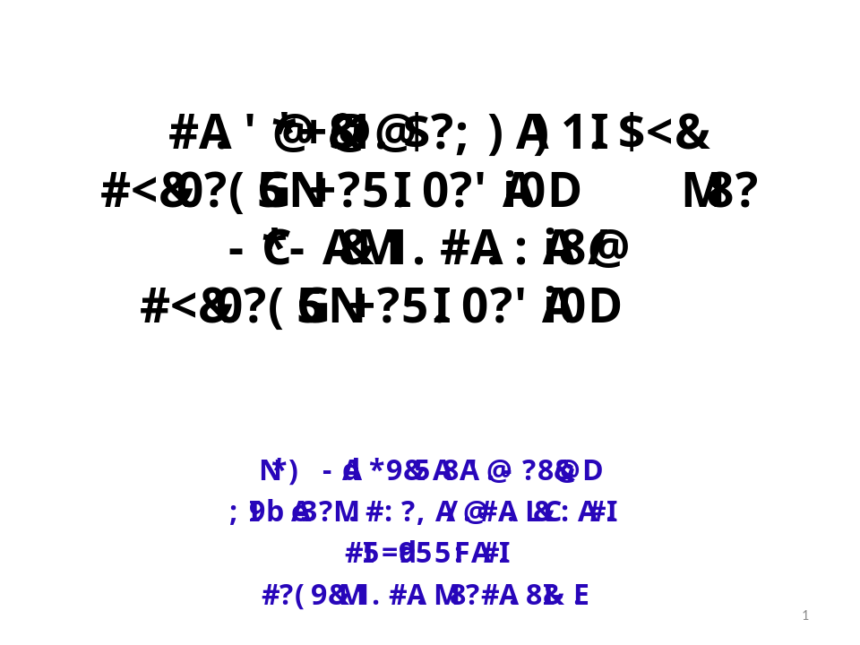

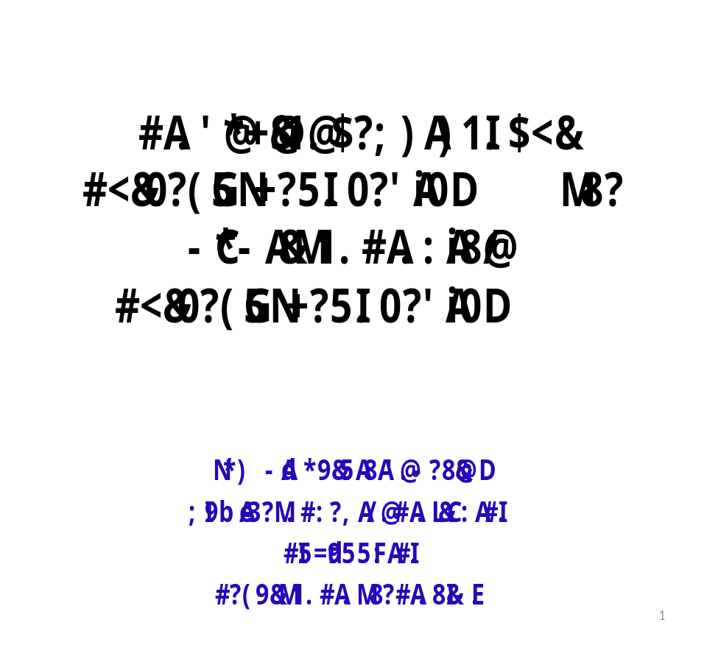

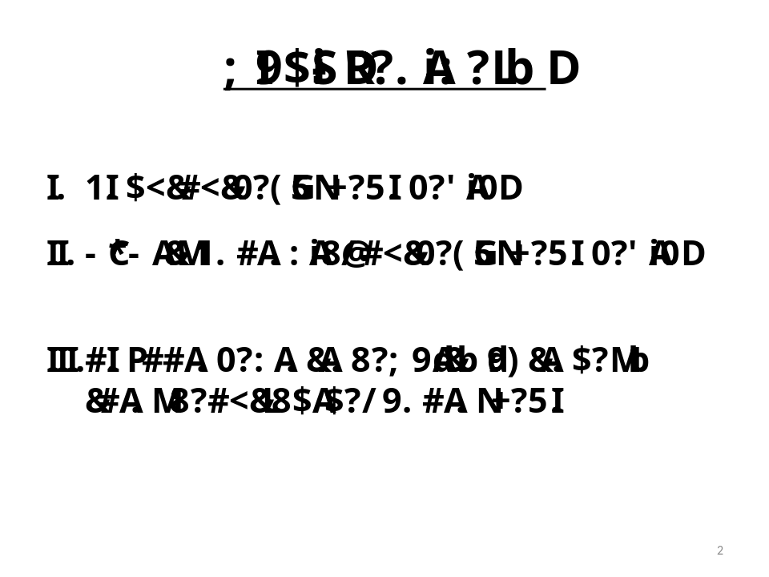

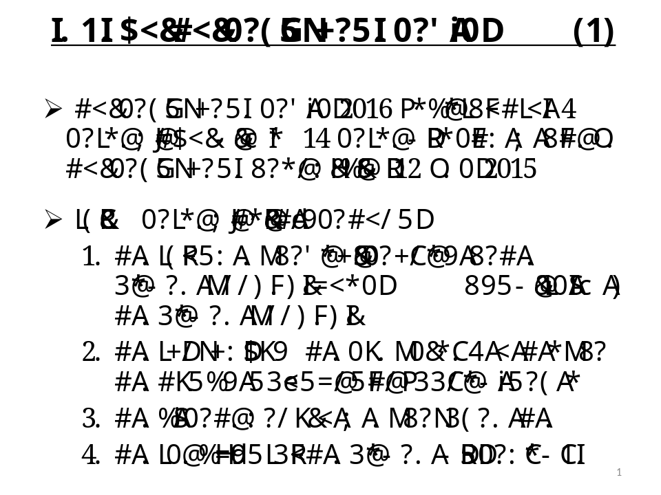

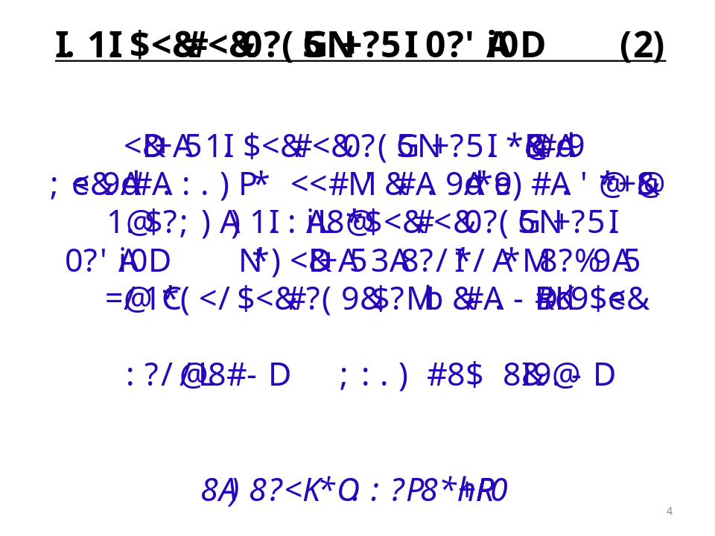

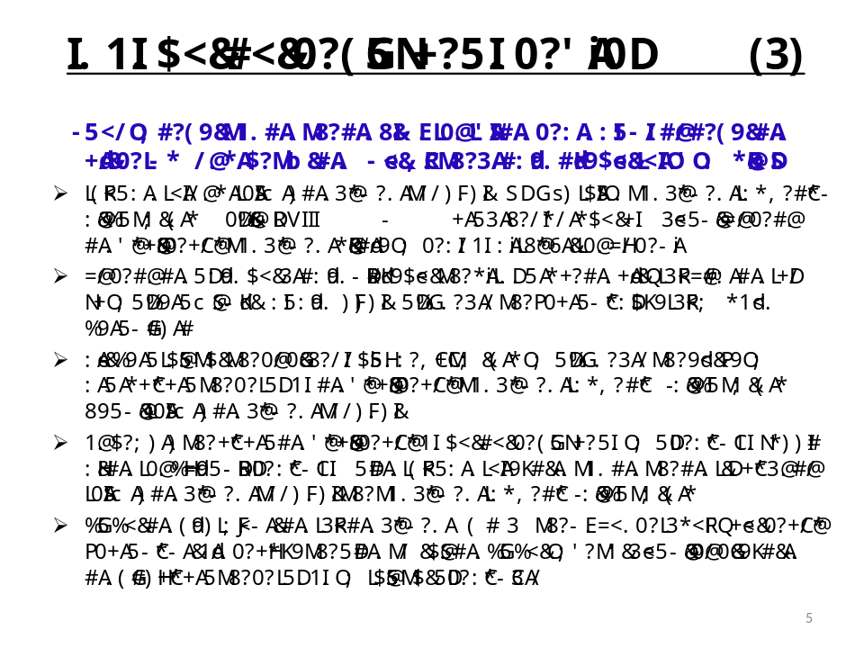

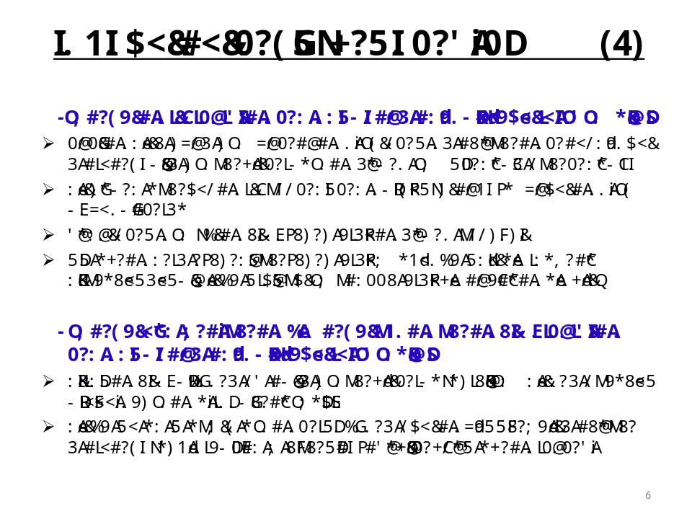

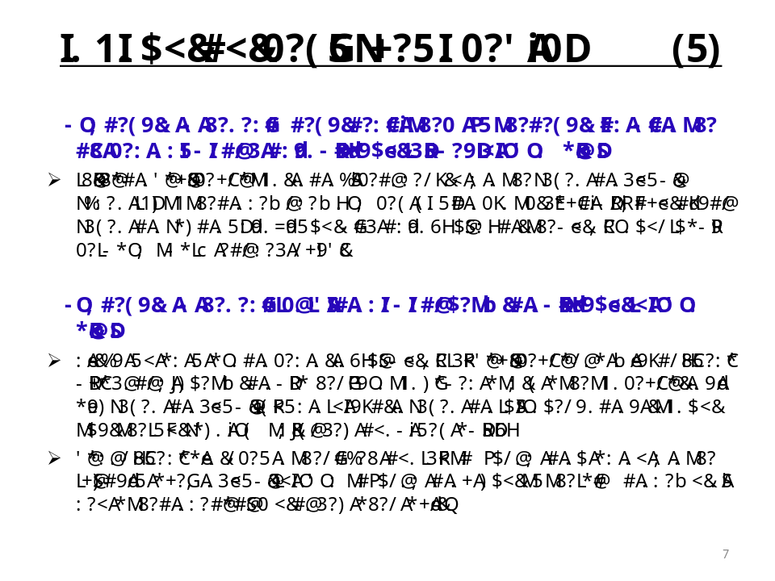

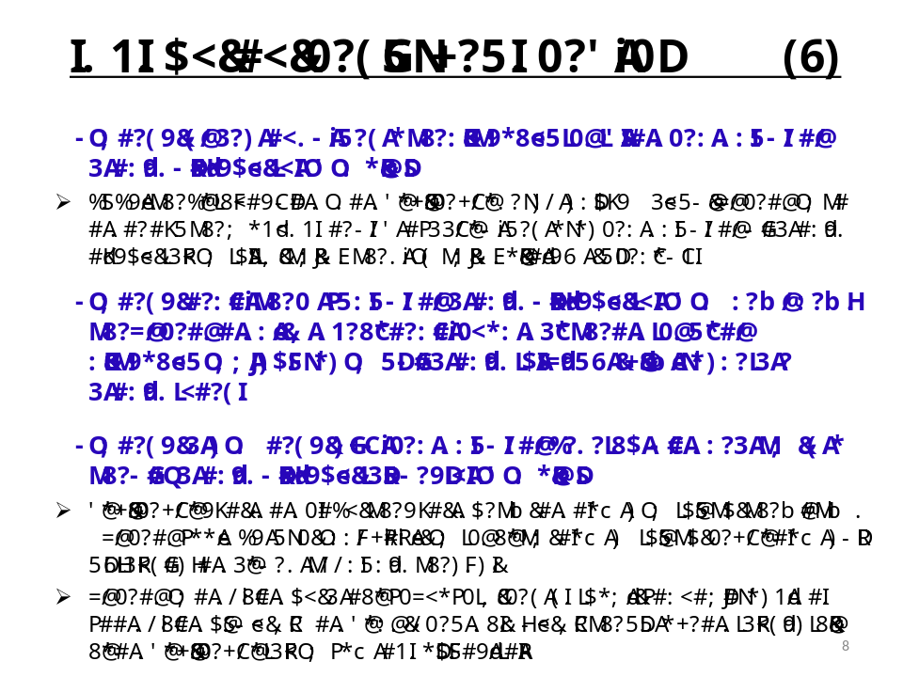

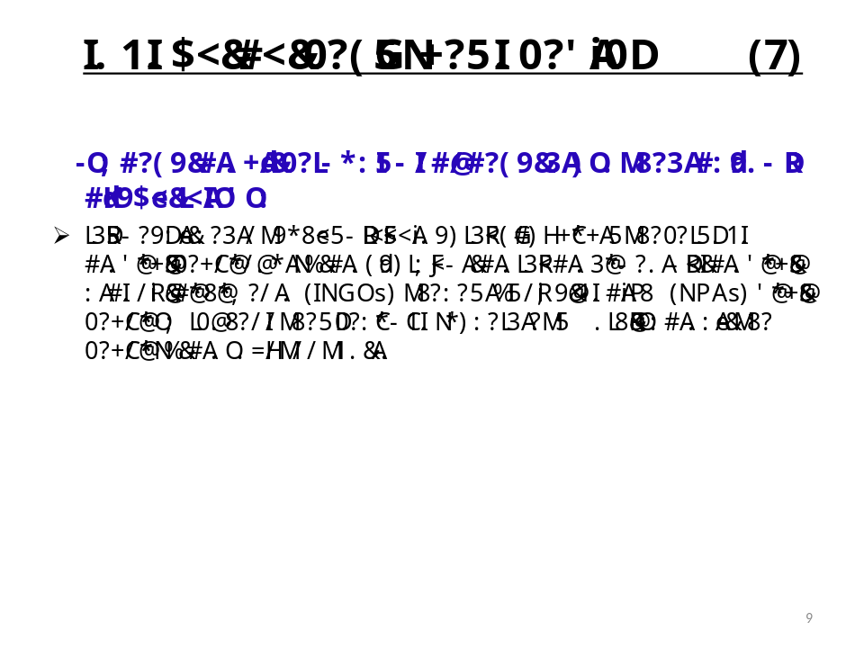
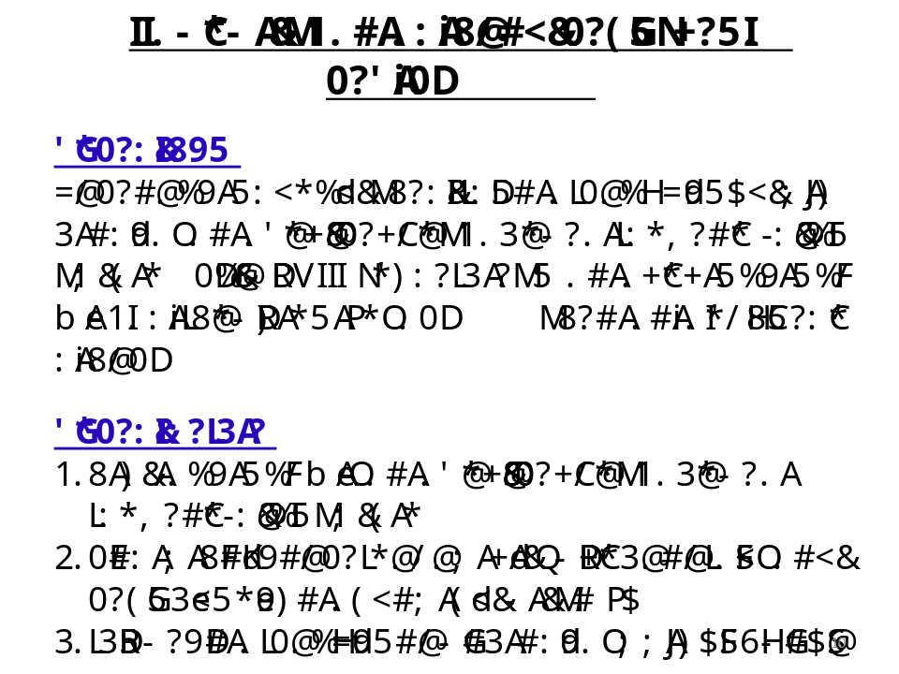
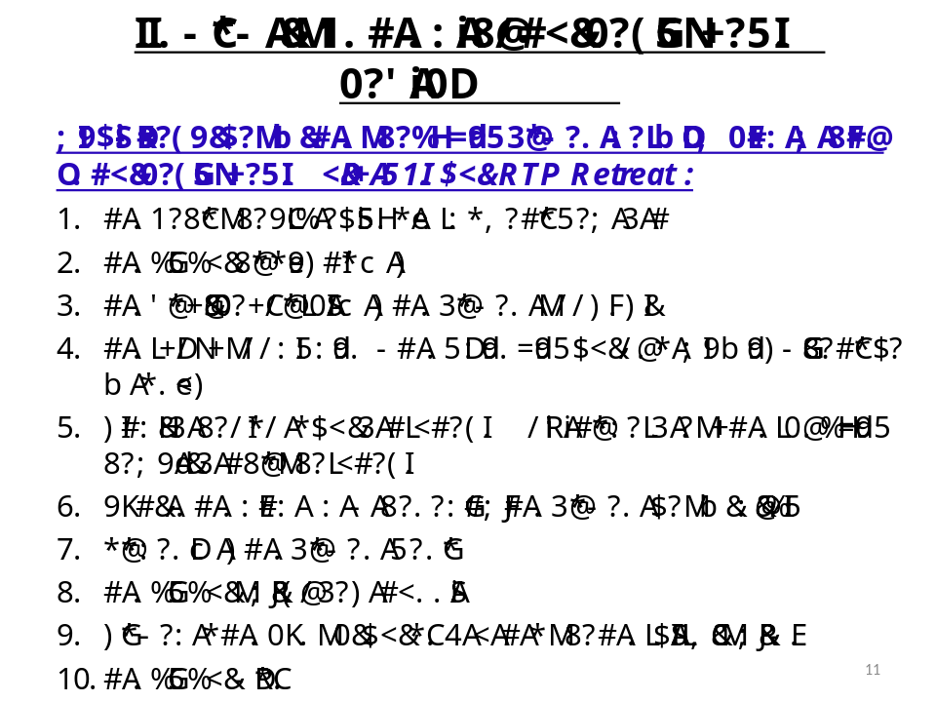
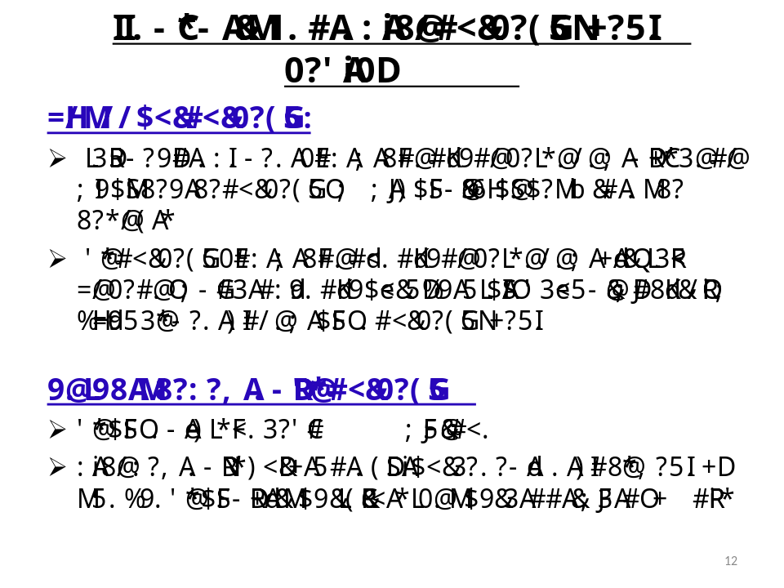
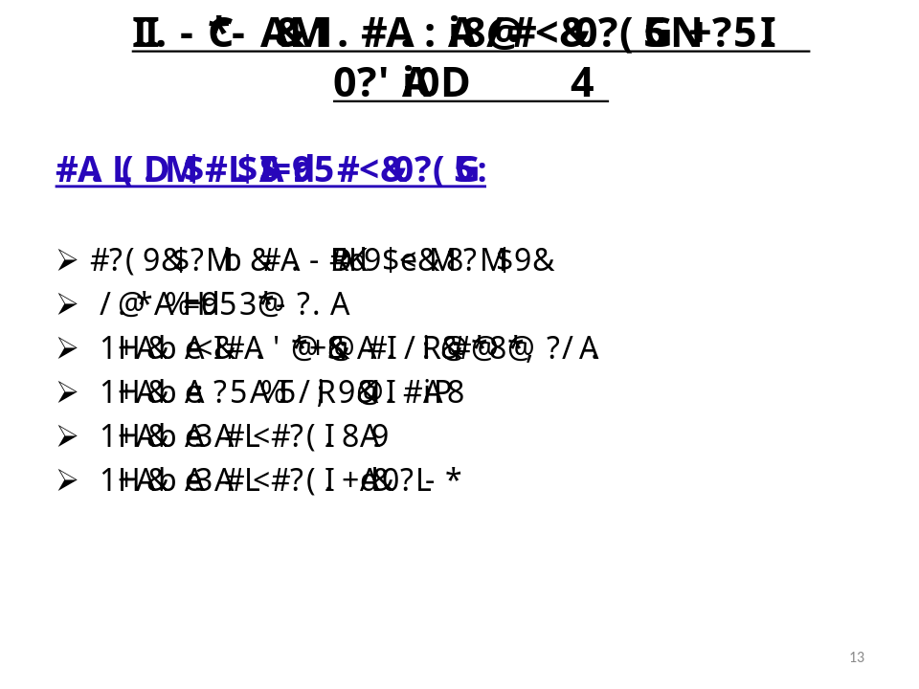
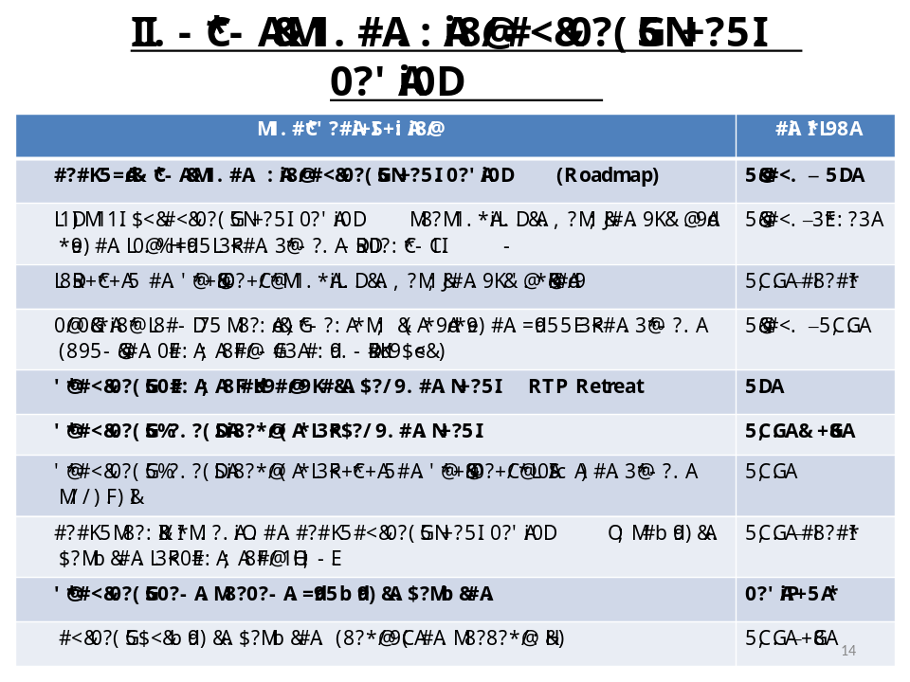
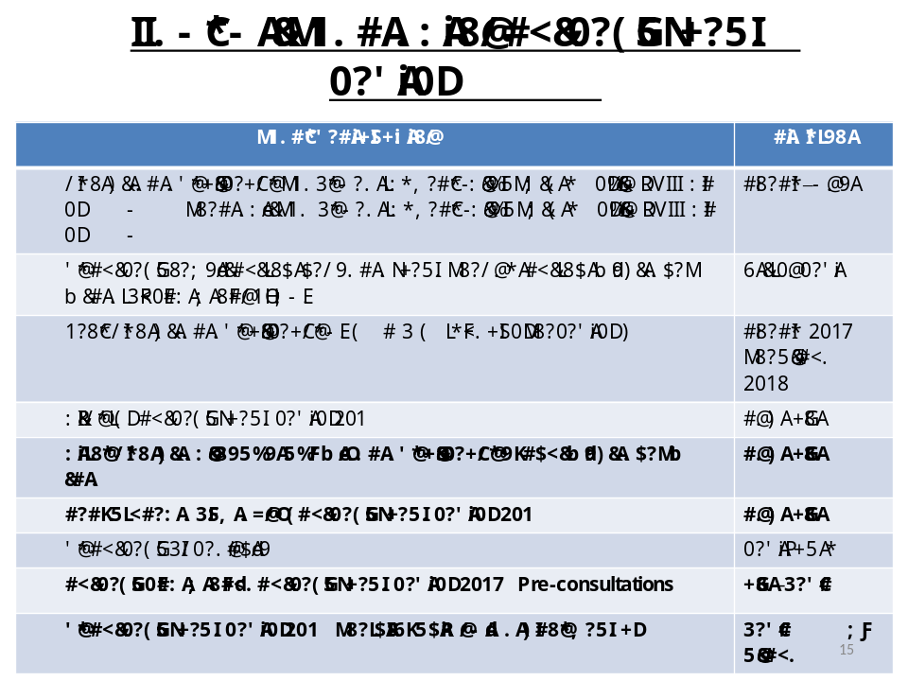
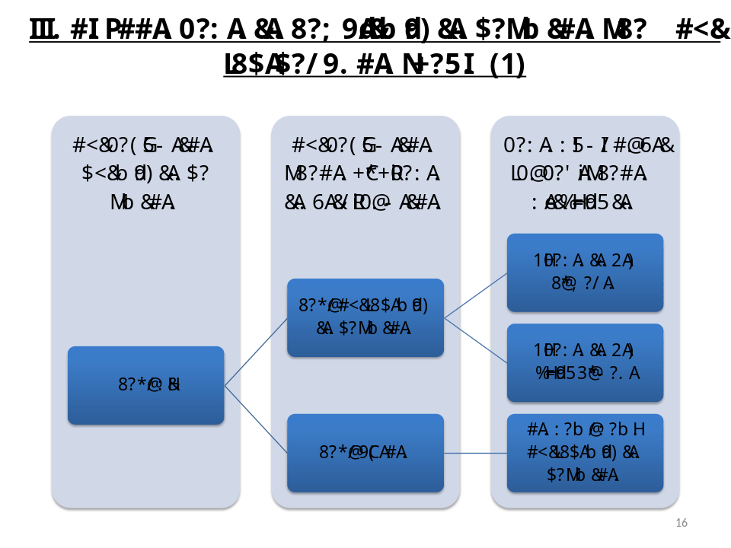
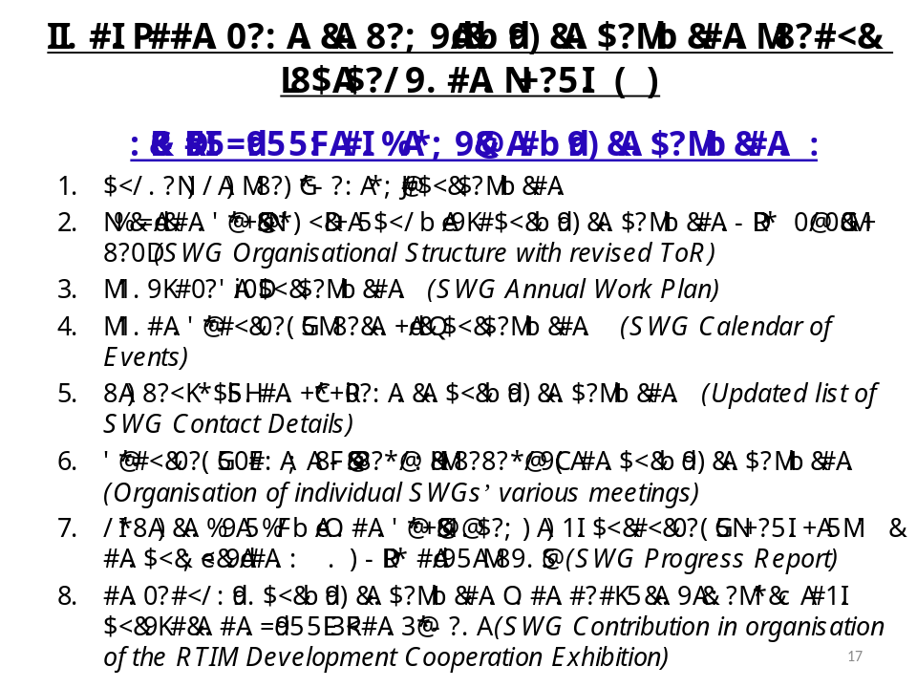

ANNEX 4: MPWT Presentation

